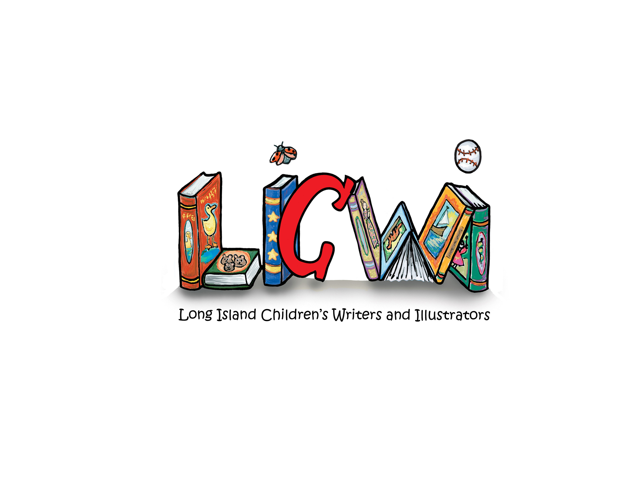

Please mail application and $40.00 check payable to “LICWI”  to: LICWI Membership  10 Sunderland St.  Melville, NY 11747  PLEASE PRINT CLEARLY |  | Note: For new members, dues paid after September 1st are applicable to the following calendar year. All others are not prorated or discounted
Full Name:
Address: | Last | First
 | Street Address | P.O. Box Apt. No.
Telephone No.: | City  Home: | State Zip  Cell:
Website (If Applicable):

Email Address:
I am an: | Author | Illustrator  Author/Illustrator
I am at least 18 years of age _____ (please confirm here)
MISSION STATMENT
Long Island Children's Writers and Illustrators (LICWI) is a monthly critique group that provides a nurturing environment to encourage, entertain, and inspire published and unpublished writers and illustrators to produce publishable works of literary and artistic excellence for children.

LONG ISLAND CHILDREN’S WRITERS AND ILLUSTRATORS
MEMBER APPLICATION
AUTHOR / ILLUSTRATOR NIGHTS - Participation by published authors and illustrators only

Author/Illustrator Nights offer an opportunity for published authors and illustrators to meet students at various schools for an evening of book signings. All interested members must have their books cleared for inclusion by the A/I Committee and must sign the A/I Night Event Rules and Guidelines agreement which you will receive shortly. Please complete the following:
Are you published in children’s literature (either traditionally or self-published)? | No  Yes
If Yes, what category? | Magazines  Books | Other
If Other, please list:  List name of publishing company  Specify: traditionally or self-published? | _________________________  _________________________  _________________________
Do you wish to attend A/I Nights? | No  Yes

SELF-PUBLISHED AUTHORS and ILLUSTRATORS - Additional instructions for A/I Night participation

IMPORTANT: If you are a self-published author or illustrator, please note that each of your books must be reviewed for grammar, literary quality, age appropriateness, and rhyme scan (if applicable) and cleared by the A/I Committee before they may be presented at Author/Illustrator Nights.

Once your membership application is processed, you will receive a Member Packet together with Author/Illustrator Night rules and guidelines and the form(s) you must send to the proofreader with your book(s).
Please

11/25/23

